


Xilinx Zynq FPGA,TI DSP,


MCU 기반의
프로그래밍 전문가 과정

날 짜 : 2018 . 5. 14

강사 – Innova Lee(이상훈)
gcccompil3r@gmail.com
학생 – 정한별
hanbulkr@gmail.com

OC_circuit

<CODE>

#include "HL_sys_common.h"
#include "HL_system.h"

#include "HL_sys_core.h"
#include "HL_mibspi.h"
#include "HL_esm.h"
#include "HL_rti.h"
#include "HL_gio.h"
#include "HL_het.h"

int main(void)
{
/* USER CODE BEGIN (3) */

rtiInit();

gioSetDirection(gioPORTA, 0xFFFFFFFF);

rtiEnableNotification(rtiREG1, rtiNOTIFICATION_COMPARE0);

_enable_IRQ_interrupt_();

rtiStartCounter(rtiREG1, rtiCOUNTER_BLOCK0);

while(1)

return 0;
}

void rtiNotification(rtiBASE_t *rtiREG, uint32 notification)
{
int i=0;
uint32 x[9]={0x00020000, 0x80000000,0x00000001,
0x00000020,0x02000000,0x00040000,0x20000000, 0x08000000,0xAA060021};

gioSetPort(gioPORTA, gioGetPort(gioPORTA) ^ x[i]);
i++;
if(i==8) i=0;
}

OC_circuit (HALCOGEN SETTING)
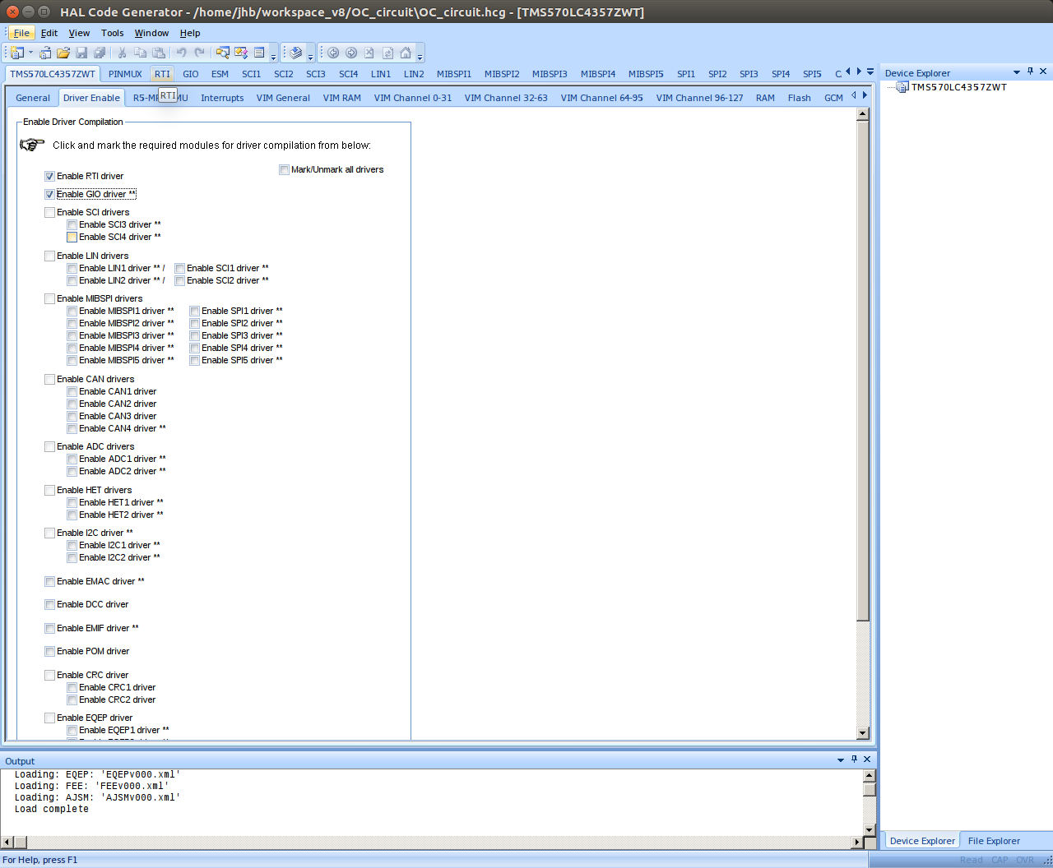

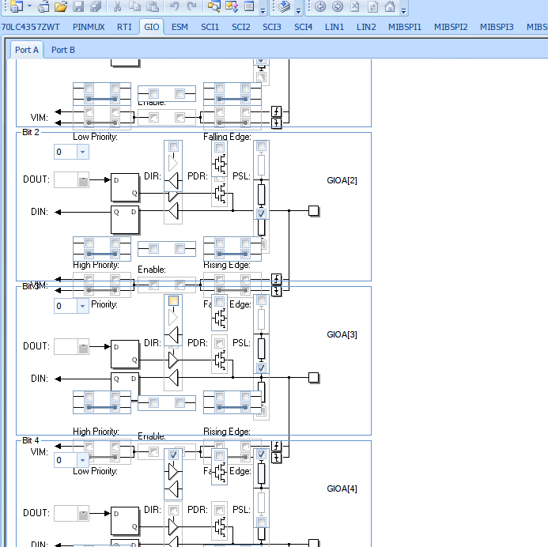

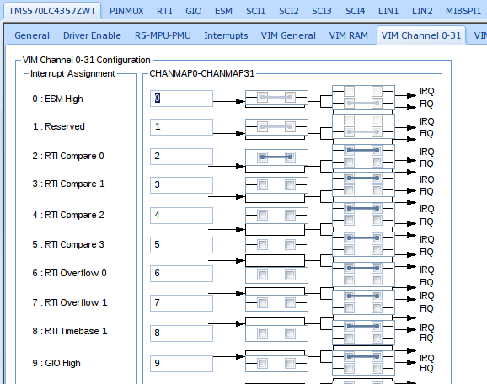

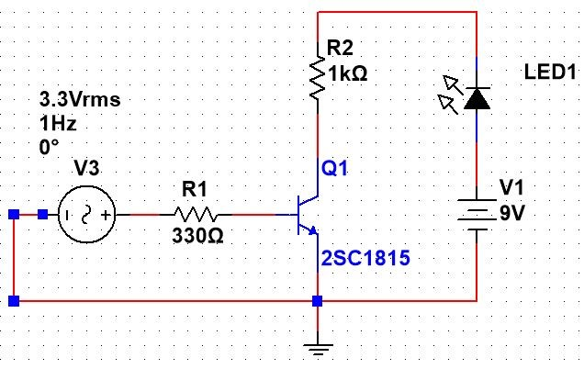

- Open Collector 회로 만들기. 베이스에서 조금의 신호를 흘려주면 스위치가 열려서 9v가 그라운드와 연결되어 전류가 흐르게 된다.

ADC_UART

<CODE>

#include "HL_sys_common.h"
#include "HL_system.h"

#include "HL_sci.h"
#include "HL_esm.h"
#include "HL_adc.h"
#include "HL_gio.h"

#define TSIZE1 12
uint8 TEXT1[TSIZE1] = { '\r', '\n', '|', '\t', 'C', 'H', '.', 'I', 'D', '-',
'0', 'x' };
#define TSIZE2 9
uint8 TEXT2[TSIZE2] = { '\t', 'V', 'A', 'L', 'U', 'E', '=', '0', 'x' };

adcData_t adc_data[2];

void sciDisplayText(sciBASE_t *sci, uint8 *text, uint32 length);
void sciDisplayData(sciBASE_t *sci, uint8 *text, uint32 length);
void wait(uint32 time);

int main(void)
{
uint32 ch_count = 0;
uint32 id = 0;
uint32 value = 0;

gioInit();
gioSetDirection(gioPORTB, 0xFF);

sciInit();

adcInit();
adcStartConversion(adcREG1, adcGROUP1);

while (1)
{
gioSetBit(gioPORTB, 0, 1);

while ((adcIsConversionComplete(adcREG1, adcGROUP1)) == 0)
;

ch_count = adcGetData(adcREG1, adcGROUP1, &adc_data[0]);

id = adc_data[0].id;
value = adc_data[0].value;

gioSetBit(gioPORTB, 0, 0);

sciDisplayText(sciREG1, &TEXT1[0], TSIZE1);
sciDisplayData(sciREG1, (uint8 *) &id, 4);
sciDisplayText(sciREG1, &TEXT2[0], TSIZE2);
sciDisplayData(sciREG1, (uint8 *) &value, 4);

if (value > 0xE00)
{
gioSetBit(gioPORTB, 4, 1);
}
else
{
gioSetBit(gioPORTB, 4, 0);
}
/*
id = adc_data[1].id;
value = adc_data[1].value;
59

sciDisplayText(sciREG1, &TEXT1[0], TSIZE1);
sciDisplayData(sciREG1, (uint8 *)&id, 4);
sciDisplayText(sciREG1, &TEXT2[0], TSIZE2);
sciDisplayData(sciREG1, (uint8 *)&value, 4);
*/
wait(0xFFFFF);

}

}

void sciDisplayText(sciBASE_t *sci, uint8 *text, uint32 length)
{
while (length--)
{
while ((sciREG1->FLR & 0x4) == 4)
;
sciSendByte(sciREG1, *text++);
}
}

void sciDisplayData(sciBASE_t *sci, uint8 *text, uint32 length)
{
uint8 txt = 0;
uint8 txt1 = 0;

#if ((__little_endian__ == 1) || (__LITTLE_ENDIAN__ == 1))
text = text + (length -1);
#endif

while (length--)
{
#if ((__little_endian__ == 1) || (__LITTLE_ENDIAN__ == 1))
txt = *text--;
#else
txt = *text++;
#endif

txt1 = txt;

txt &= ~(0xF0);
txt1 &= ~(0x0F);
txt1 = txt1 >> 4;

if (txt <= 0x9)
{
txt += 0x30;
}
else if (txt > 0x9 && txt < 0xF)
{
txt += 0x37;
}
else
{
txt = 0x30;
}

if (txt1 <= 0x9)
{
txt1 += 0x30;
}
else if ((txt1 > 0x9) && (txt1 <= 0xF))
{
txt1 += 0x37;
}
else
{
txt1 = 0x30;
}

while ((sciREG1->FLR & 0x4) == 4)
;
sciSendByte(sciREG1, txt1);

while ((sciREG1->FLR & 0x4) == 4)
;
sciSendByte(sciREG1, txt);
}
}

void wait(uint32 time)
{
int i;
for (i = 0; i < time; i++)
;
}

ADC_UART (HALCOGEN SETTING)
